**Risk-based evaluations of competing agronomic climate adaptation strategies: The case of rice planting strategies in the Indo Gangetic Plains**

Maxwell Mkondiwa,1 Anton Urfels2,3

1 CIMMYT International Maize and Wheat Improvement Center, New Delhi, India

2 International Rice Research Institute (IRRI), Los Baños, The Philippines

3 Water Resources Management Group, Wageningen University & Research, Wageningen, NL

# Abstract

CONTEXT: Adjusting crop planting dates and variety durations is emerging as a crucial climate change adaptation strategy for many cereal systems. Such strategies include harmonizing crop planting with the onset of the rainy season or planting at specific recommended calendar dates. Evaluations of these strategies mostly consider yield and yield variability, but focus less on financial risks associated with different planting strategies. However, choosing recommendations amongst competing levels of yield and yield stability is not straightforward and need to cater to farmers that are risk averse – especially financially.

OBJECTIVE: Here, we present a novel framework that uses a computational spatial ex-ante approach using golden section search algorithm and second order stochastic dominance for risk-based evaluations of agronomic adaptation options. This framework allows development of climatic risk proof recommendations such that even risk averse farmers would find it profitable to adopt that strategy

METHODS: We use a second order stochastic dominance approach that is paired with computational optimization—Golden section search algorithm. To demonstrate our approach, we compare the yield risks and economic risks associated with readily available gridded crop simulation outputs for various rice planting strategies across the Indo-Gangetic Plains – a major region experiencing food insecurity and climate impacts.

RESULTS AND CONCLUSIONS: Our findings provide quantitative evidence about the riskiness of previously recommended rice planting date strategies. Our risk-based assessment corroborates the recommendation for planting long-duration varieties at the monsoon onset in the Eastern IGP, and at state-recommended planting dates in most of the Western and Middle IGP. Importantly, our risk-based assessment shows where the results are not as clear cut and which strategy is the least risky. This is especially important in the Middle IGP where farmers appear to have more flexibility to achieve comparable outcomes with several planting strategies.

SIGNIFICANCE: In conclusion, our approach provides a useful and novel tool for comparing different agronomic climate adaptation strategies from an economic risk perspective in a spatial framework.

# Graphical Abstract

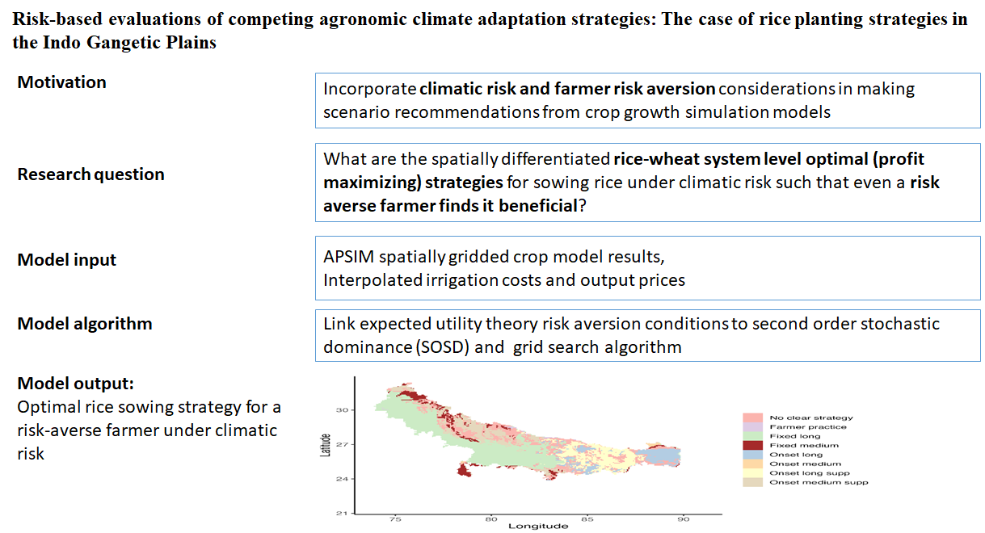

**Keywords:** sustainable agriculture, spatial economics, climate resilience, irrigation, smallholder farmers

# 1. Introduction

Climate change is predicted to have a largely negative impact on the agricultural systems of low and middle income countries IPCC (2022). To adapt, farmers and policy makers must choose between several competing agronomic response options. Researchers usually evaluate these options based on average yield levels, water use, and income across years with varying weather conditions and provide subsequent recommendations (Kakraliya et al., 2018; Tesfaye et al., 2019). However, comparing these different indicators and assessing acceptable levels of variability is not straightforward resulting in recommendations based on qualitative expert judgement and mean comparisons that disregard downside risks. Using means for evaluation agronomic response options is especially inadequate for risk averse smallholder farmers that seek to minimize any losses they may have to incur (Ruzzante, Labarta, & Bilton, 2021). How, for example, shall one evaluate an adaptation strategy that, across several years, has been shown to require an average of 50mm additional water use to gain 300 kg of yield, 10% more income and increase yield variability by 5%? The main aim of this paper is to develop a climatic risk proofing framework for making recommendations on rice sowing strategies in the IGP using evidence from crop growth models.

Deriving recommendations for rice planting in the rice-wheat cropping systems of the Indo-Gangetic Plains (IGP) is a case in point. In the IGP, rice is planted in the monsoon season from June to October (also called kharif) while wheat is grown as an irrigated crop in winter season from November to April (also called rabi). Climate impacts on agricultural systems of the IGP are amongst the most severe globally (IPCC, 2022), as, e.g., late monsoon onsets delay rice sowing in the Eastern IGP and push wheat crops into periods of high terminal heat stress – while farmers in the Western IGP use free electricity to plant their rice crops early in the hot summer months and contribute to groundwater depletion. Recent compelling evidence suggests that advancing the planting date of rice to match the monsoon onset is a crucial adaptation option for farmers in the Eastern IGP – and might help to alleviate groundwater depletion in the Western IGP (Ishtiaque et al., 2022; McDonald et al., 2022; Montes et al., 2023; Newport et al., 2020; Urfels et al., 2021; Urfels et al., 2022; Wang et al., 2022). To test this hypothesis, Urfels et al (2022) and subsequently, working with the same datasets, Montes et al (2023) use gridded crop simulations for the Indo-Gangetic Plains to investigate the impact of different rice planting strategies (combining sowing dates, variety duration and irrigation) on system level productivity, resilience, and environmental benefits. However, most farmers are risk averse and not only interested in long-term profit maximization and yield outcomes (Ruzzante, Labarta, & Bilton, 2021). It is thus important to consider economic risks and not just average yield and yield variability when evaluating agronomic adaptation strategies. For example, recent studies Hurley, Koo and Tesfaye (2018); Suri (2011) have shown that year to year variation in economic returns to adopting technologies can result in lower levels of adoption of generally profitable agricultural innovations – but approaches for evaluation agronomic strategies from a risk perspective remain scarce.

To address this knowledge gap, we deploy a climatic risk proofing framework to select suitable adaptation strategies for risk-averse farmers. To demonstrate our approach, we evaluate the riskiness of adopting various rice planting strategies across the IGP by re-evaluating the results of crop the model simulations of various rice planting strategies across the IGP by Urfels et al. (2022).

This paper contributes to two strands of literature. The first strand of literature is on stability analyses of agricultural technology benefits based on ex-ante cropping system assessments (Urfels et al., 2022). Montes et al. (2023) used inter-annual standard deviation to analyse the stability of the planting date scenarios. Urfels et al. (2022) used deviation from the mean caloric yield for each of the years when a shock occurred as a measure of yield instability. These measures of yield stability, while a step better than mean comparisons, they do not consider robustness of the optimal decision to risk aversion of the farmers. In addition, these measures do not consider higher order moments beyond mean and variability that may matter for distributional comparisons. In addition, we argue that mean comparisons do not consider the trade-offs for achieving highest returns and reducing uncertainty. So far, most studies address uncertainty by, for example, using model ensembles or Monte Carlo simulations (Iizumi, Yokozawa, & Nishimori, 2009; Rosenzweig et al., 2013). But these approaches only allow for establishing confidence in the mean and variation around it and do not adequately take into account the implied risks to farmers.

These limitations are addressed in the second strand of literature which focuses on the spatial risk assessment of economic benefits of agricultural innovations (Nalley & Barkley, 2010). This literature attempts to optimize on the trade-offs of achieving the highest return and lowest uncertainty therefore allows one to choose strategies that are more robust. Using modern portfolio theory (Markowitz, 1959) which suggests that a strategy to maximize average returns may be a suboptimal strategy, (Nalley & Barkley, 2010) used a mean-variance analysis to optimally select wheat varieties that achieve highest return and lowest risk. This strategy still suffers from the limitation of using a subset of moments (mean and variance) of the distribution. The stochastic dominance approach was developed to resolve these concerns in selecting robust strategies (Levy, 2016). Using long term weather data, crop simulation model results (APSIM), spatially explicit observed maize prices, and fertilizer prices; (Hurley, Koo, & Tesfaye, 2018) simulates whether weather risk affects the adoption of fertilizer and improved maize seeds. They use heterogeneity in soils and climate in a calibrated crop growth model to simulate the distributions of yields across adoption of fertilizer and improved maize seed scenarios.

We specifically follow the approach proposed by Hurley, Koo and Tesfaye (2018)[1] to estimate willingness to pay bounds for a risk averse farmer to likely adopt an alternative rice planting date strategy. The key idea of the willingness to pay bounds is that there is an amount of economic gain that will make one choose a new strategy in the sense of second order stochastically dominating the base strategy. Similarly, there is an amount that would make them indifferent. The algorithm uses a golden section search optimization approach to select the maximum and minimum numbers that satisfy these conditions. We depart from their approach in three substantial ways. First, instead of fertilizers and improved varieties, we consider multiple management changes including sowing dates, irrigation amounts, and varieties differing on duration to maturity. This allows a more realistic comparisons of the benefits of the interrelated crop management decisions rather than a piecemeal and partial analysis of specific decisions. Second, we consider a rice-wheat multi-crop system unlike Hurley, Koo and Tesfaye (2018) who focus on maize only. This has the added value that the optimal decision in one crop may be suboptimal for the next season there providing the trade-offs that farmers make when making adjustments in one crop. Third, we do not only consider pairwise comparisons but also use the willingness to pay bounds to select the best strategy among multiple competing options. This has the advantage that we can select one optimal strategy among the many to recommend for risk averse farmers. Our application shows how this risk-assessment framework can handle increasingly complex decisions.

The rest of the paper is organized as follows. We present next the methods focusing on the computational risk assessments. In section 3 we present results and discussion of the yield and economic benefits of alternative planting date strategies. We finally conclude in section 4.

# 2. Methods

In this section, we showcase and explain our risk-assessment framework. We first explain the framework from a theoretical perspective. Subsequently, we briefly explain how we use the gridded APSIM simulation outputs from Urfels et al. (2022) to illustrate our approach.

In short, we illustrate our approach in the Results section by (i) comparing the different planting strategies by crop and their yield risks, (ii) systems level revenue, and (iii) system level partial profits. Finally, (iv) we determine the most optimal planting strategy for risk averse farmers for each grid-cell across the IGP. To determine which strategy performs best from a risk perspective, we use a novel method to estimate willingness to pay bounds through a stochastic dominance approach to determine which rice planting strategies are both economically beneficial and least risky. To assess economic returns, we multiply the simulated yield outcomes with spatially explicit price data for rice and wheat. Since the only variable cost of in the simulation is irrigation amount, we consider their impact on the outputs and calculate partial profits using common irrigation cost of US$1.26 per m3 (Shah et al., 2009; Urfels et al., 2020) and multiply it with the total irrigation amount required in each simulation.

The remainder of this Methods section provides an overview of (i) our risk assessment approach and (ii) more details on the input data.

## 2.1. Computational spatial ex-ante economic model under risk aversion

Our framework uses a two-step approach: First we evaluate systems-level yield risks and subsequently systems level economic risks. For both yield risks and economic risks, we assess adaptation options through a willingness to pay (WTP) lens that considers both economic performance and riskiness. The guiding question is: How much would a farmer be willing to pay for an adaptation option and still be clearly better off than with the baseline? To assess this, we assume that an adaptation option is suitable for risk averse farmers if the distribution (not just the average) of yield and economic outcomes supersedes the baseline so that the chance of having inferior outcomes is reduced. Using the so called ‘second order stochastic dominance’ (SOSD) – a well-established measure in decision theory for comparing the riskiness inherent in two distributions – we assess whether the adaptation option is less risky than the baseline (i.e. negative outcomes less likely). Below we provide an overview of how SOSD works for our case. For more details regarding SOSD and risk aversion, please see Levy (2016) and (Meyer, 1977) for a detailed explanation.

## 2.2. Comparing the riskiness of two agronomic adaptation options

To evaluate the riskiness of an adaptation option regarding either yield or economic returns, we compute spatially explicit willingness to pay bounds in rice and wheat yield equivalents that define, for a risk averse farmer, whether that farmer would adopt a technology or not. SOSD provides an estimate of which option is risker and Hurley, Koo and Tesfaye (2018) computational modelling helps to assess how much better it is. Importantly, our WTP bounds are not symmetrical and, in principle, the WTP bounds we use can be thought of as follows (i) how much the cumulative distribution of the adaptation option can be shifted to the left (i.e. the benefits uniformly reduced) and still outperform the baseline (lower bound), and (ii) how much the cumulative distribution function can be moved to the right (i.e. the benefits uniformly increased) before it is entirely on the right side of the baseline (upper bound). In other words, how much is a farmer will a farmer gain (willing to pay) when adopting the adaptation strategy (lower bound). And how much would a farmer need to pay in addition to adopting the adaptation option to reduce his risk of losing against the baseline to zero (upper bound).

To demonstrate this approach, we use a hypothetical experiment shown in Figure 1. Based on mean comparisons, is clearly better than and . If we think in terms of distributional differences, is clearly better than because the cumulative distribution curve of is wholly to the right of . This is also called first order stochastic dominance. Consider the next case, where and are having crossing cumulative distribution functions. Visually, it can be assessed that has a higher mean and much lower likelihood of low performing outcomes. G has a higher mean and is less risk. This is, G second order stochastically dominates . Since the cumulative distribution function of G and F are crossing each other, neither distribution first order stochastically dominates the other.

Lastly, consider the case of and , they are crossing each other and have the same mean. It is difficult to visually assess which one is more risky – i.e. determine the second order stochastic dominance ordering for these technologies.

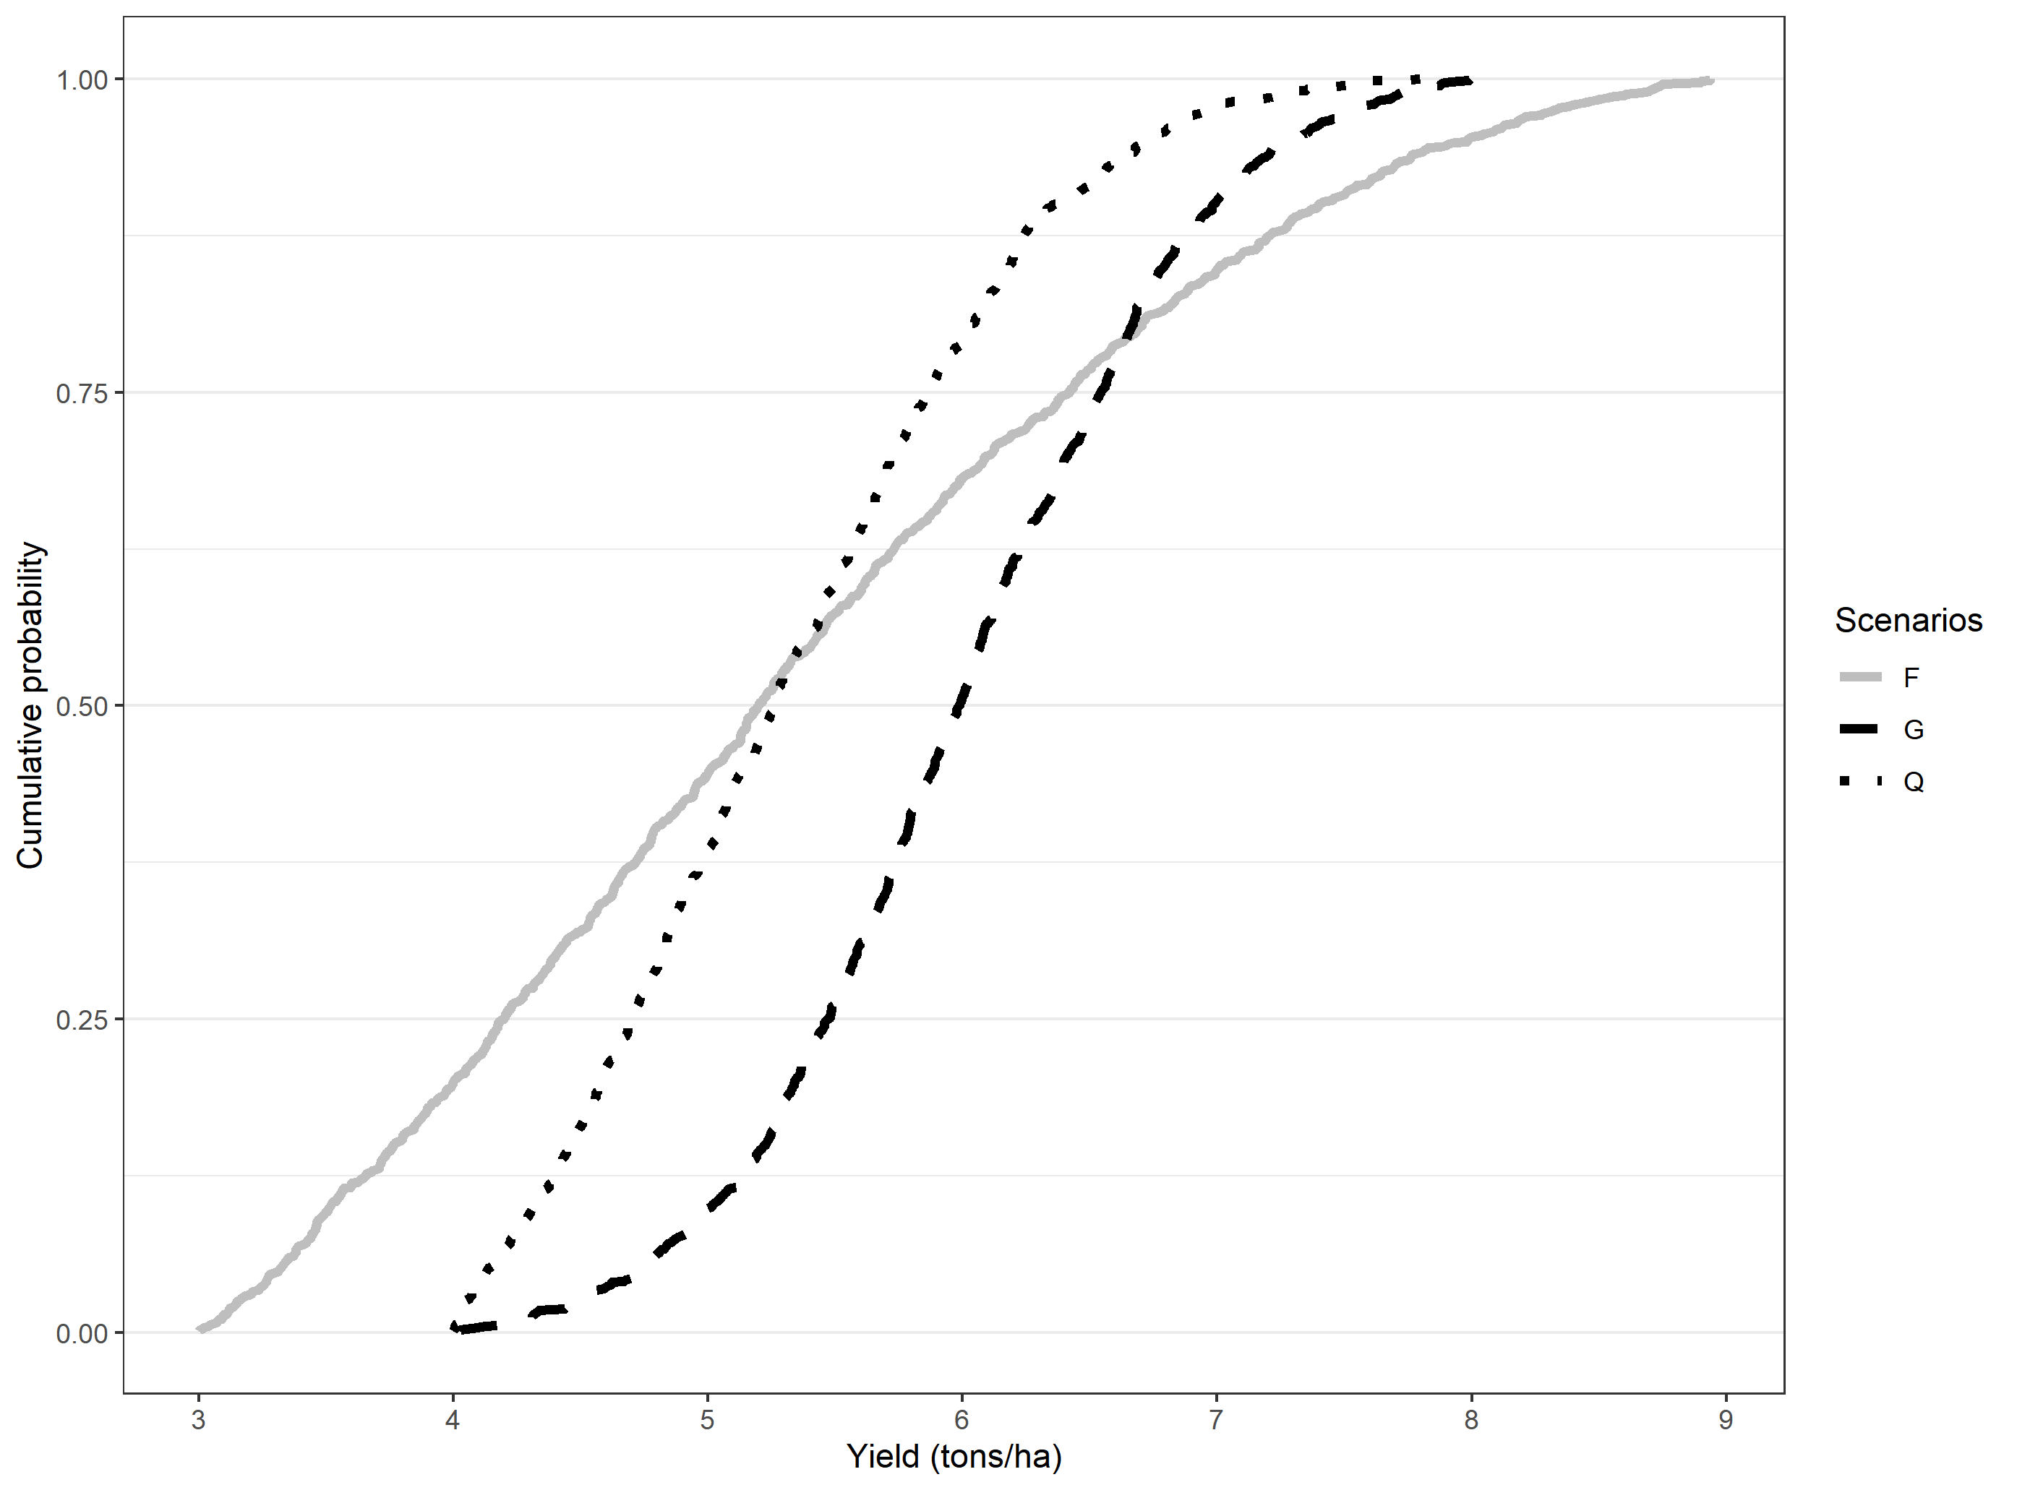

Figure 1: Hypothetical stochastic dominance assessment

***Note:*** We use a truncated normal distribution with four parameters: minimum (a), maximum (b), mean, and standard deviation (sd). The parameters used for each of the scenarios are as follows: G= rtruncnorm (n=1000,a=4,b=8, mean=6,sd=0.8), Q=rtruncnorm (n=1000,a=4,b=8, mean=5,sd=1), F=rtruncnorm (n=1000,a=3,b=9, mean=5,sd=2).

The lower WTP bound that makes any risk-averse farmer prefer new technology (in this case scenarios other than the baseline) can be derived using second order stochastic dominance (see Hurley, Koo and Tesfaye (2018) for detailed derivations). If both lower bound and upper bound are positive, then any risk averse farmer will prefer the new technology. Conversely, if both lower bound and upper bound are negative, then any risk averse farmer will stick to the old technology. If however, the lower bound is negative and the upper bound is positive, then it is requires an explicit understanding of risk preferences—information not easily available—to determine which distribution is preferred. We use Octave for the computational analyses.

Proceeding with the hypothetical distributions, we show in table 1 results from using our approach to compute upper and lower willingness to pay bounds. The WTP bounds are positive for the comparison between Q and G as well as F and G.

Table 1: Hypothetical distributions and willingness to pay bounds

|  |  |  |  |
| --- | --- | --- | --- |
| Panel (a): Truncated normal distribution parameters for the hypothetical distributions | | | |
| Truncated normal parameters | G | Q | F |
| N | 1000 | 1000 | 1000 |
| Min=a | 4 | 4 | 3 |
| Max=b | 8 | 8 | 9 |
| Mean | 6 | 5 | 5 |
| SD | 0.8 | 1 | 2 |
| **Panel (b): Willingness to pay bounds from computational second order stochastic dominance assessment** | | | |
|  | Q(base)  vs G | Q vs F | F vs G |
| WTP lower bound (ton/ha) | 0.036 | 0 | 0.499 |
| WTP upper bound (ton/ha) | 0.763 | 0.218 | 1.384 |
| Interpretation | G SOSD Q | Not clear | G SOSD F |

The sign for the WTP bounds gives the evaluation of the benefits of the technology for a risk averse farmer. If both upper and lower bounds are positive, the farmer is willing to pay for that strategy. The upper bound is the amount of money that would pay just to stay with the new technology and thus abandon because it is second order stochastically dominated, while the lower bound is the amount that would pay just to be indifferent between the new strategy and the base strategy. For negative WTP for upper and lower bound, it shows that they would need to be paid to accept the proposed strategy. Lower bound is the amount of money that they would accept to abandon their existing strategy. Upper bound is the amount of money that they would accept just to be indifferent between the new strategy and their existing strategy[2].

## 2.3. APSIM spatially gridded crop model scenarios

The data used in this paper was based on gridded APSIM crop growth simulation model results for climate variables for the period 1982-2015 reported in Urfels et al. (2022)[3]. The model was run using spatial resolution input data and the original study includes extensive performance evaluation for validating the results and modelling setup with other datasets on reported phenology and yield outcomes. We use seven scenarios from crop simulation results reported in (Urfels et al., 2022). The scenarios correspond to variation in irrigation, varietal duration and the planting of rice at the onset of the monsoon. Table 2 shows the details for the scenarios. We used the fixed long (S1) scenario as the baseline scenario. This scenario involves planting long duration rice variety at a fixed recommended date based on a state recommendation. We considered this as the baseline scenario instead of the farmer practice (S0) because S1 had observations for all pixels in the area of interest unlike the farmer practice which due to limitations of data had a limited number of pixels[4].

Table 2: Scenarios

|  |  |  |
| --- | --- | --- |
| Scenario number | Rice planting strategy | Description |
| S0 | Farmer practice | Farmers’ practice baseline without nutrient and water limitations to understand current limits |
| **S1** | **Fixed long (baseline scenario)** | **Planting long duration variety at a fixed recommended date (state recommendation)** |
| S2 | Fixed medium | Planting medium duration variety at a fixed recommended date |
| S3 | Onset long | Planting long duration rice variety at the onset of monsoon |
| S4 | Onset long supp | Only providing supplementary irrigation for planting long duration varieties at monsoon onset |
| S5 | Onset medium | Planting medium duration variety at monsoon onset |
| S6 | Onset medium supp | Supplementary irrigation for planting medium varieties at monsoon onset |

We supplement the APSIM model results with spatially gridded rice and wheat prices from the Landscape Crop Assessment Survey (LCAS; <https://systems-agronomy.github.io/lcas/>) data interpolated using a random forest model based on population density and back of the envelope spatially gridded irrigation costs approximated for rented tubewells (most expensive) as 1.26 USD per m3 (Shah et al., 2009; Urfels et al., 2020). To calculate system revenues, we used grid cells level prices of rice and wheat to compute the revenues of following each of the scenarios. The grid cells level prices are obtained by interpolating prices from the Landscape Crop Assessment Survey (LCAS) for 2017/18 season. We then use these economic indicators in the stochastic comparisons.

## 2.4. Systems level economic benefits and risks

For cropping system assessment, we focus on the revenues and partial profits (revenue-cost of irrigation) derived from both rice and wheat. Willingness to pay is therefore in monetary terms rather than quantity terms. We use the same approach as stated above to determine if it is beneficial for a risk averse farmer to adopt the planting date strategy. When the revenue and partial profit WTP is compared between the baseline and the proposed strategy, we get the revenue and profit potential for the farmers in each grid cells.

# 3. Results

Here we present our results to evaluate the yield and economic risks associated with different rice planting strategies that were simulated across the Indo-Gangetic Plains. We first present results for rice and wheat yields and subsequently assess the performance for system level economic returns and their risks. We use the state recommended calendar dates for rice planting as a baseline (not the farmers’ practice) as it is a more clear-cut strategy (one calendar date for each the Western, Middle, and Eastern IGP) than the remotely sensed farmers’ practice. Our results are in line with previous analyses (McDonald et al., 2022; Newport et al., 2020; Urfels et al., 2021) and provide additional evidence on the riskiness of different rice planting strategies that have not previously been considered and allow identification of the that outperformance other strategies without increased downside risk in each grid cell.

## 3.1. Risk adjusted yield benefits of different rice planting strategies in the IGP

Figure 2 and 3 provide a geographical overview of where each strategy outperforms the baseline. While the results generally corroborate the findings from the previous crop simulations reported in (Urfels et al., 2022), our risk-based framework allows us to identify spatially demarcated zones where risk averse farmers might want to switch strategies and where multiple strategies can work similarly well for risk averse farmers – a feature that could only be assessed through visual assessment in the previous study.

### 3.1.1. Rice yields and their riskiness

Table 3 shows the descriptive statistics on the willingness to pay bounds (ton/ha) in rice yield equivalent for the planting date scenarios in comparison to the fixed date with long duration variety planting strategy. The WTP summary rows show the percentage of farmers who are more likely to (a) benefit, (b) be worse off or (c) be indifferent between the planting date strategies. Only 31% of the farmers would find the planting long duration rice varieties at the monsoon onset as beneficial followed by planting medium duration varieties at the recommended calendar dates medium (30%). For farmer practice, the average and median WTP bounds (both lower and upper) are negative implying that farmers are overall worse off using their current rice planting strategies.

Table 3: Rice WTP bounds with fixed long as baseline, IGP

|  |  |  |  |  |  |  |  |
| --- | --- | --- | --- | --- | --- | --- | --- |
| Bound | Statistics | S0-S1 | S2-S1 | S3-S1 | S4-S1 | S5-S1 | S6-S1 |
| Upper bound | Mean | -1.03 | 1.90 | 0.76 | 0.41 | 1.32 | 1.01 |
| Std.Dev | 1.36 | 1.75 | 2.50 | 2.38 | 1.79 | 1.76 |
| Min | -5.65 | -2.47 | -5.58 | -5.65 | -4.23 | -4.38 |
| 10th percentile | -2.17 | -1.60 | -2.26 | -2.35 | -1.65 | -1.53 |
| 25th percentile | -1.85 | 1.32 | -0.58 | -0.88 | 0.66 | -0.47 |
| Median | -1.33 | 2.48 | 0.04 | -0.30 | 1.77 | 1.53 |
| 75th percentile | -0.45 | 3.04 | 3.18 | 2.86 | 2.38 | 2.20 |
| 90th percentile | 0.15 | 3.52 | 4.11 | 3.68 | 3.06 | 2.93 |
| Max | 5.92 | 5.64 | 5.73 | 5.65 | 10.95 | 8.90 |
| Lower bound | Mean | -3.53 | -0.73 | -1.42 | -2.02 | -1.27 | -1.49 |
| Std.Dev | 1.68 | 1.73 | 2.60 | 2.47 | 1.78 | 1.68 |
| Min | -7.83 | -4.69 | -7.02 | -6.16 | -7.02 | -7.20 |
| 10th percentile | -5.53 | -2.47 | -5.13 | -5.19 | -2.75 | -3.20 |
| 25th percentile | -4.62 | -2.03 | -3.76 | -4.41 | -2.28 | -2.52 |
| Median | -3.71 | -1.15 | -0.71 | -1.87 | -1.51 | -1.82 |
| 75th percentile | -2.32 | 0.35 | 0.18 | -0.14 | -0.34 | -0.54 |
| 90th percentile | -1.89 | 1.92 | 1.90 | 1.18 | 1.16 | 0.73 |
| Max | 4.84 | 5.05 | 4.79 | 4.66 | 8.50 | 6.49 |
| WTP summary | Clearly better (share) | 0.02 | 0.30 | 0.31 | 0.21 | 0.21 | 0.18 |
| Not clear (share) | 0.11 | 0.52 | 0.21 | 0.19 | 0.59 | 0.53 |
| Clearly worse (share) | 0.87 | 0.18 | 0.49 | 0.60 | 0.21 | 0.29 |
| Number of cells | 17411.00 | 17412.00 | 17420.00 | 17421.00 | 17421.00 | 17421.00 |

Note: The number of cells are lower for S0-S1, S2-S1 and S3-S1 due to missing information in some of the grid cells.

Figure 2 shows for which grid cells the proposed planting strategy is clearly better, clearly worse, or neither better or worse than the state recommended planting dates with long duration varieties. Among these, planting a long duration variety with monsoon onset seems to provide much advantage in the eastern part of IGP. The western part seems to benefit more from the fixed date recommendation with long duration varieties. The yield trends have been discussed in Urfels et al. (2022), pointing out the Middle IGP is a transition zone. Our risk-based approach corroborates these findings and provides additional insight into the transition areas where we can clearly demarcate when one strategy supersedes the baseline, and where several strategies provide comparable benefits (e.g. see Figure 2c).

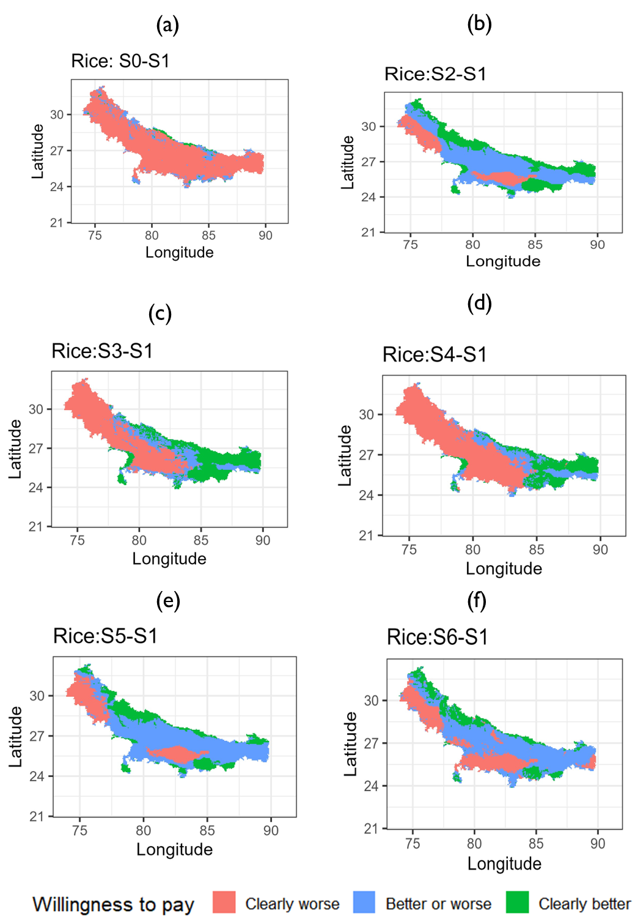

Figure 2: Willingness to pay (rice yield ton/ha) for the strategy against a fixed long duration variety reference strategy (S1) using second order stochastic dominance. Note: S0 to S6 are as defined in table 2 where S0=farmer practice, S1=fixed long (baseline), S2=fixed medium, S3=onset long, S4=onset long supplemental irrigation, S5=onset medium, S6=onset medium supplemental irrigation.

### 3.1.2. Wheat yields and their riskiness

Like in rice, our results for wheat show how rice planting strategies affect the wheat crops – which is grown directly after rice harvest and its planting date thus strongly dependent on the rice planting date. Table 4 shows descriptive statistics of the willingness to pay bounds in wheat yield equivalent (ton/ha) for the scenarios in comparison to fixed date recommendation with long duration rice variety rice planting strategy (here after called fixed long strategy). Column (S0-S1) shows the comparison between farmer practice and fixed long strategy. It is apparent from the lower bound estimates, almost 90% of farmers have negative WTP lower bound for the farmer practice strategy when compared with the fixed long strategy. For about 25% of these, even the upper WTP is negative. Farmer practice is a good strategy for risk averse farmers for only about 4% of the grid cells. For wheat the best strategy seems to be planting medium duration varieties and state recommended calendar dates in that most of grid cells (86%) will benefit with higher wheat yields as compared to the fixed long rice planting strategy.

Table 4: Wheat WTP bounds (ton/ha) with fixed date-long variety scenario as baseline, IGP

|  |  |  |  |  |  |  |  |
| --- | --- | --- | --- | --- | --- | --- | --- |
| Bound | Statistics | S0-S1 | S2-S1 | S3-S1 | S4-S1 | S5-S1 | S6-S1 |
| Upper bound | Mean | -0.50 | 1.00 | 0.22 | -0.88 | 0.17 | -0.65 |
| Std.Dev | 0.83 | 0.46 | 0.64 | 1.19 | 0.70 | 1.14 |
| Min | -5.47 | -0.08 | -1.16 | -4.06 | -1.56 | -4.19 |
| 10th percentile | -1.89 | 0.28 | -0.58 | -2.55 | -0.76 | -2.19 |
| 25th percentile | -0.71 | 0.71 | -0.18 | -1.78 | -0.42 | -1.63 |
| Median | -0.29 | 1.09 | 0.08 | -0.79 | 0.20 | -0.50 |
| 75th percentile | 0.00 | 1.34 | 0.54 | -0.06 | 0.75 | 0.29 |
| 90th percentile | 0.28 | 1.53 | 1.28 | 0.77 | 1.11 | 0.75 |
| Max | 1.59 | 1.99 | 2.05 | 1.91 | 1.78 | 1.61 |
| Lower bound | Mean | -1.94 | 0.49 | -0.37 | -1.69 | -0.37 | -1.62 |
| Std.Dev | 1.45 | 0.37 | 0.83 | 1.45 | 0.79 | 1.47 |
| Min | -7.00 | -0.55 | -2.29 | -6.67 | -2.29 | -6.67 |
| 10th percentile | -3.88 | -0.02 | -1.49 | -3.69 | -1.50 | -3.65 |
| 25th percentile | -3.15 | 0.27 | -0.90 | -2.97 | -1.01 | -2.83 |
| Median | -2.14 | 0.49 | -0.37 | -1.64 | -0.21 | -1.70 |
| 75th percentile | -0.58 | 0.70 | 0.15 | -0.52 | 0.28 | -0.17 |
| 90th percentile | -0.04 | 1.07 | 0.79 | 0.29 | 0.47 | 0.24 |
| Max | 1.34 | 1.34 | 1.62 | 1.49 | 1.35 | 1.23 |
| WTP summary | Clearly better (share) | 0.04 | 0.86 | 0.28 | 0.15 | 0.40 | 0.20 |
| Not clear (share) | 0.20 | 0.12 | 0.35 | 0.09 | 0.19 | 0.14 |
| Clearly worse (share) | 0.75 | 0.01 | 0.37 | 0.76 | 0.41 | 0.66 |
| Number of cells | 17421.00 | 17421.00 | 17421.00 | 17421.00 | 17421.00 | 17421.00 |

However, there is a clear spatial structure to these results. Figure 3 shows the spatial distribution of willingness to pay classifications categorizing strategies on wheat yield whether they are worse, better or worse, and better than the fixed long rice planting strategy. Fixed planting of a medium duration rice variety seems to be the best strategy to ensure higher wheat yields across most locations in the IGP except in the northwestern IGP where one would be indifferent (12%). Besides, the Eastern IGP also performs well with planting long duration varieties at the monsoon onset, which is much earlier in the Eastern IGP than in the Western IGP.

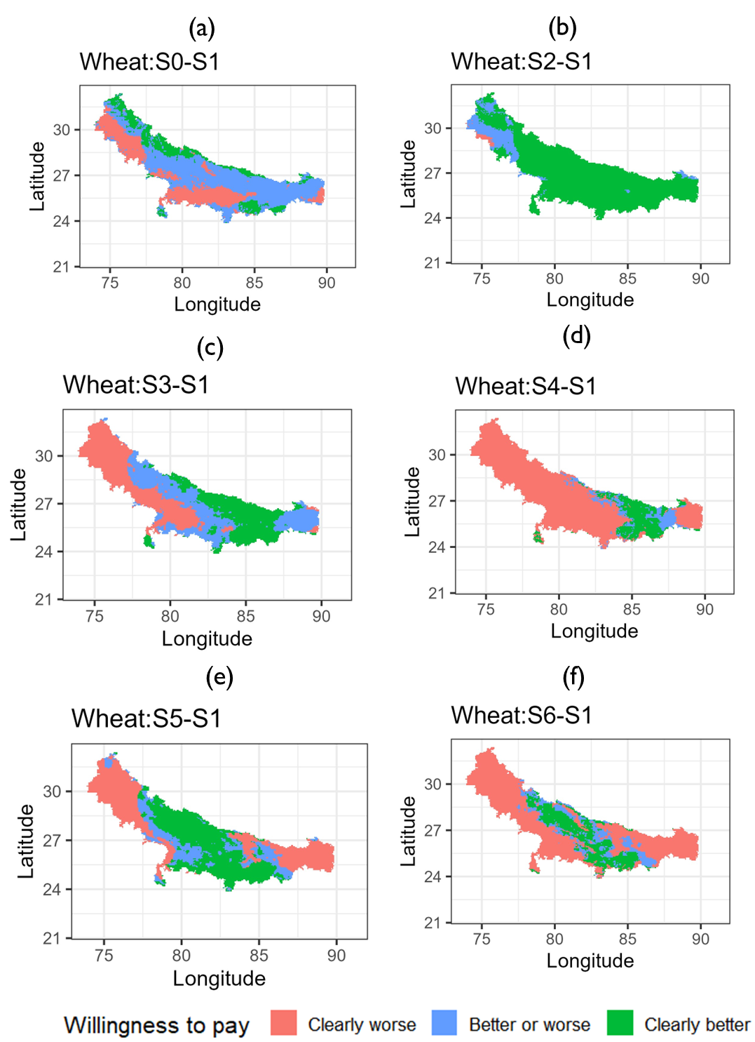

Figure 3: Willingness to pay (wheat yield ton/ha) for the strategy against a fixed long duration variety reference strategy using second order stochastic dominance. Note: S0 to S6 are as defined in table 2 where S0=farmer practice, S1=fixed long (baseline), S2=fixed medium, S3=onset long, S4=onset long supplemental irrigation, S5=onset medium, S6=onset medium supplemental irrigation.

## 3.2. System-wide economic benefits for a risk averse farmer

The above yield-based risk assessment likely matter most to subsistence farmers. Most farmers in the IGP, however, sell some parts of their produce (Urfels et al., 2023). Fully evaluating the system level risks thus requires an economic evaluation across both crops. We first provide an overview of the revenue and associated risks, followed by a more profit-oriented analysis that includes partial costs incurred for irrigation as this is the only cost variable that varies across our scenarios.

### 3.2.1. System revenues

Table 5 shows the descriptive statistics for the willingness to pay bounds. Starting with the percentage of grid cells that would benefit from each of the scenarios as compared to the baseline, the WTP summary rows show that farmers’ practices is the worst performing strategy across the IGP (column 3) with 78% losing compared to the state recommended planting dates. This is followed by planting medium duration varieties at the monsoon onset with constrained irrigation (column 8) that results in 52% of cells clearly worse off than the baseline.

Table 5: Gross revenue WTP (thousand rupees/ha) bounds with fixed long as baseline

|  |  |  |  |  |  |  |  |
| --- | --- | --- | --- | --- | --- | --- | --- |
| Bound | Statistics | S0-S1 | S2-S1 | S3-S1 | S4-S1 | S5-S1 | S6-S1 |
| Upper bound | Mean | -23.99 | 34.99 | 8.37 | -14.67 | 14.30 | 1.49 |
| Std.Dev | 25.96 | 28.30 | 41.11 | 47.53 | 29.59 | 31.35 |
| Min | -144.09 | -28.54 | -84.72 | -125.24 | -64.90 | -89.49 |
| 10th percentile | -56.03 | -15.52 | -45.24 | -74.99 | -26.87 | -37.83 |
| 25th percentile | -39.27 | 22.03 | -19.37 | -51.28 | -4.45 | -19.90 |
| Median | -24.18 | 41.04 | 1.34 | -18.60 | 15.28 | -1.92 |
| 75th percentile | -12.33 | 56.10 | 39.14 | 20.11 | 36.06 | 25.19 |
| 90th percentile | 1.85 | 66.82 | 69.81 | 56.16 | 53.93 | 45.26 |
| Max | 87.55 | 91.16 | 96.57 | 86.07 | 132.20 | 108.48 |
| Lower bound | Mean | -73.43 | -1.39 | -18.36 | -43.68 | -16.67 | -28.19 |
| Std.Dev | 36.34 | 25.91 | 43.02 | 49.08 | 28.35 | 30.59 |
| Min | -177.76 | -59.94 | -123.07 | -139.93 | -119.55 | -151.45 |
| 10th percentile | -113.83 | -28.09 | -77.92 | -109.68 | -46.58 | -65.46 |
| 25th percentile | -94.35 | -20.99 | -53.41 | -86.66 | -30.70 | -43.60 |
| Median | -72.95 | -6.29 | -13.44 | -42.45 | -19.58 | -29.30 |
| 75th percentile | -56.20 | 16.31 | 10.49 | -3.30 | -1.85 | -11.96 |
| 90th percentile | -29.14 | 36.79 | 37.99 | 22.05 | 20.96 | 11.44 |
| Max | 83.40 | 69.35 | 87.03 | 76.56 | 113.90 | 83.34 |
| WTP summary | Clearly better (share) | 0.02 | 0.42 | 0.36 | 0.23 | 0.23 | 0.16 |
| Not clear (share) | 0.09 | 0.42 | 0.16 | 0.14 | 0.44 | 0.32 |
| Clearly worse (share) | 0.89 | 0.16 | 0.48 | 0.63 | 0.32 | 0.52 |
| Number of cells | 17456.00 | 17456.00 | 17456.00 | 17456.00 | 17456.00 | 17456.00 |

These results show that there is no one size fits all strategy and we further investigate the spatial structure to better understand the performance of different rice planting strategies across the IGP. Spatially, there are pockets for which a risk averse farmer would not switch to the recommended fixed date with long duration variety strategy especially in the central grid cells of Bihar. Again, the spatial structure of the results shows where, due to interannual weather risks, farmers may fare best to choose one specific strategy and where they might be similarly well off with more than strategy.

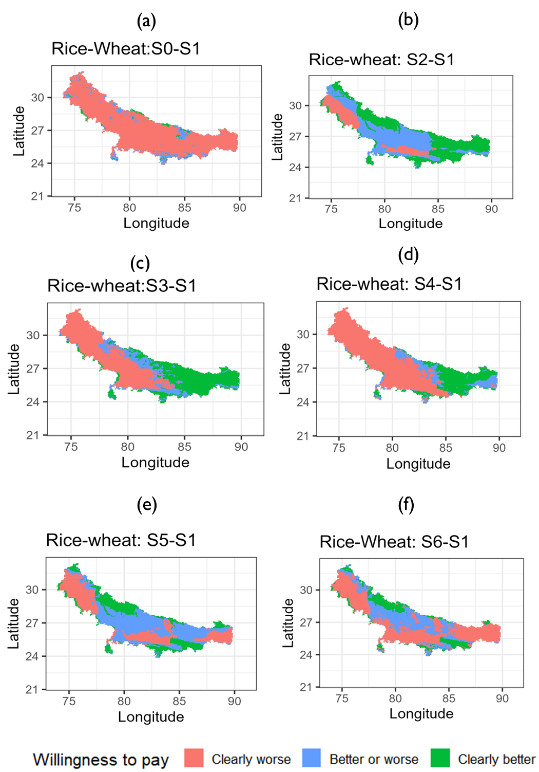

Figure 4: Spatial distribution of revenue WTP (where to target the scenarios). Note: S0 to S6 are as defined in table 2 where S0=farmer practice, S1=fixed long (baseline), S2=fixed medium, S3=onset long, S4=onset long supplemental irrigation, S5=onset medium, S6=onset medium supplemental irrigation.

### 3.2.2. System partial profits

When considering partial profits as incurred by the varying irrigation costs, the results again show that there is no one size fits all solution for the IGP with no single rice planting strategy outperforming others. Table 6 shows descriptive statistics for willingness to pay for partial profits (revenue-irrigation costs) for each of the planting date strategies as compared to fixed date-long duration rice variety strategy. As with productivity and revenue comparisons, farmer practice is a worse strategy for about 85% of the grid cells in IGP. None of the strategies dominate across the entire IGP as can be seen in figure 5.

Table 6: Partial profits WTP (thousand rupees/ha) descriptive statistics

|  |  |  |  |  |  |  |  |
| --- | --- | --- | --- | --- | --- | --- | --- |
| Bound | Statistics | S0-S1 | S2-S1 | S3-S1 | S4-S1 | S5-S1 | S6-S1 |
| Upper bound | Mean | -15.31 | 40.40 | 12.30 | 7.84 | 23.80 | 25.40 |
| Std.Dev | 22.82 | 28.98 | 42.88 | 46.27 | 31.34 | 34.62 |
| Min | -97.77 | -25.01 | -80.65 | -95.69 | -62.89 | -82.90 |
| 10th percentile | -36.40 | -10.73 | -42.52 | -49.44 | -21.58 | -17.54 |
| 25th percentile | -26.88 | 24.88 | -16.26 | -27.25 | 7.19 | -1.91 |
| Median | -18.74 | 47.15 | 2.00 | 1.43 | 24.04 | 23.22 |
| 75th percentile | -8.09 | 62.14 | 48.44 | 41.74 | 48.21 | 52.55 |
| 90th percentile | 6.10 | 72.21 | 77.33 | 79.22 | 63.93 | 74.15 |
| Max | 99.85 | 96.57 | 103.13 | 112.42 | 137.49 | 129.42 |
| Lower bound | Mean | -50.40 | 3.51 | -16.12 | -24.19 | -8.78 | -5.70 |
| Std.Dev | 26.63 | 25.83 | 44.08 | 47.57 | 28.33 | 32.81 |
| Min | -126.29 | -54.20 | -115.70 | -112.73 | -103.66 | -118.82 |
| 10th percentile | -79.57 | -23.43 | -73.37 | -82.82 | -38.10 | -47.72 |
| 25th percentile | -66.27 | -16.27 | -54.83 | -66.11 | -23.19 | -23.23 |
| Median | -52.75 | -0.94 | -13.87 | -28.33 | -12.87 | -6.43 |
| 75th percentile | -35.94 | 20.98 | 16.24 | 13.97 | 6.85 | 12.31 |
| 90th percentile | -21.19 | 41.44 | 44.49 | 43.67 | 29.05 | 36.92 |
| Max | 89.66 | 76.40 | 90.44 | 97.08 | 120.33 | 99.99 |
| WTP summary | Clearly better (share) | 0.02 | 0.49 | 0.37 | 0.31 | 0.32 | 0.38 |
| Not clear (share) | 0.13 | 0.37 | 0.18 | 0.21 | 0.48 | 0.35 |
| Clearly worse (share) | 0.85 | 0.14 | 0.45 | 0.48 | 0.21 | 0.27 |
| Number of cells | 17420.00 | 17420.00 | 17420.00 | 17420.00 | 17420.00 | 17420.00 |

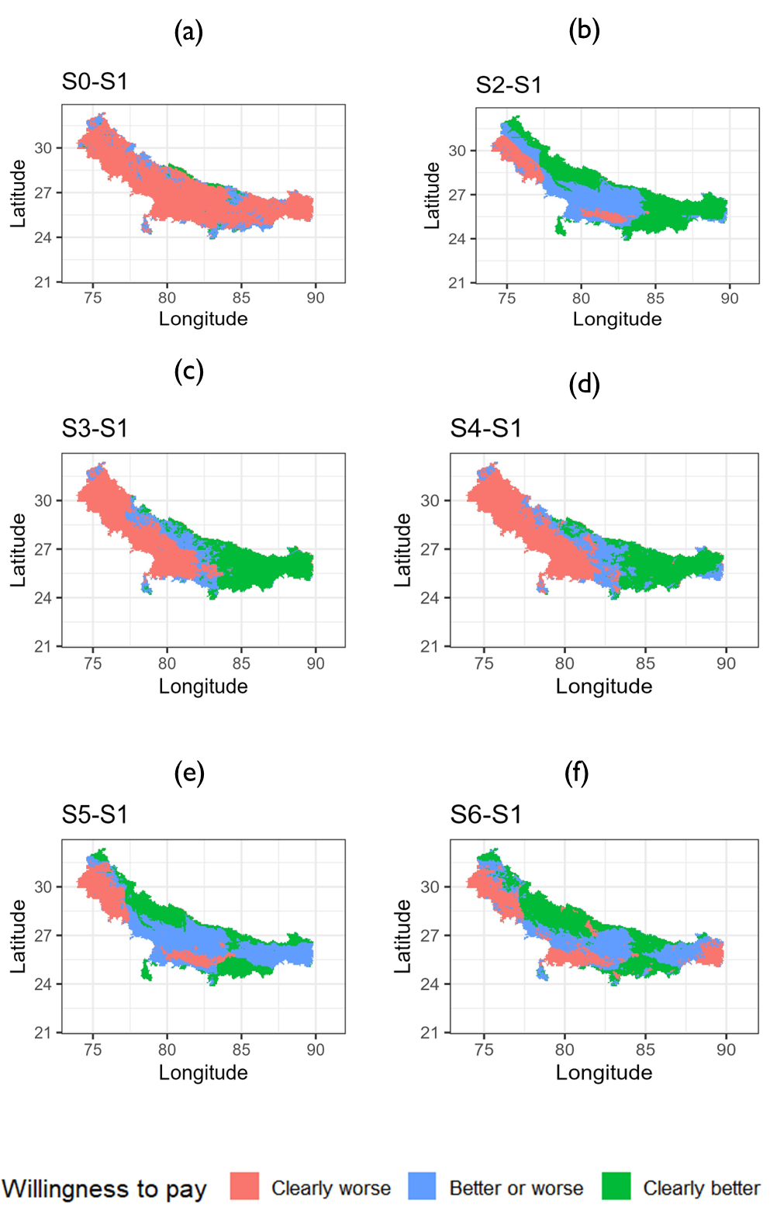

Figure 5: Spatial distribution of partial profit WTP (where to target the scenarios). Note: S0 to S6 are as defined in table 2 where S0=farmer practice, S1=fixed long (baseline), S2=fixed medium, S3=onset long, S4=onset long supplemental irrigation, S5=onset medium, S6=onset medium supplemental irrigation.

The preceding results have been interpreted on the basis of whether the strategy is better, worse or unclear based on whether the lower bound and upper bound are all positive, all negative or only lower bound is negative respectively. We use bounds in making this determination because in a distributional comparison of the adaptation options it is not possible to pin down one value. The use of willingness bounds however has another advantage beyond what we have shown with discrete choices, i.e., better, worse, unclear. It is that the magnitude of each of the bound provides insights on downside and upside risk as well as the ambiguity of the adaptation option (the wider, the more ambiguous).

On average for example, planting long duration rice at monsoon onset remains less risky and overall beneficial for farmers up to a reduction in partial returns by the lower WTP bound of Rs. 12,300 per ha (~US$ 153.75 at an exchange rate of 1:80). This could happen, for example, if there was an increase in irrigation or a decrease in grain prices, both of which are common and likely scenarios. At the same time, a uniform increase of US$ 201.5 would render this strategy risk-free vis-a-vis the baseline strategy. Given that no average farmer or pixel exists for which these two average bounds would occur simultaneously, these numbers are best evaluated at pixel level as shown in figure 6. There are areas of the Eastern IGP where partial profits of the onset-long strategy are almost risk-free requiring reduction of profits of over US$1000 for any risk averse farmer to consider the baseline. These areas can be clearly prioritized for the onset-long strategy. Of course, our profit data is only partial, and a full real-world recommendation should consider more comprehensive profit analyses - but even such partial analyses based on crop modelling results can provide decision makers with valuable ex-ante insights into the riskiness of adopting different climate adaptation strategies.

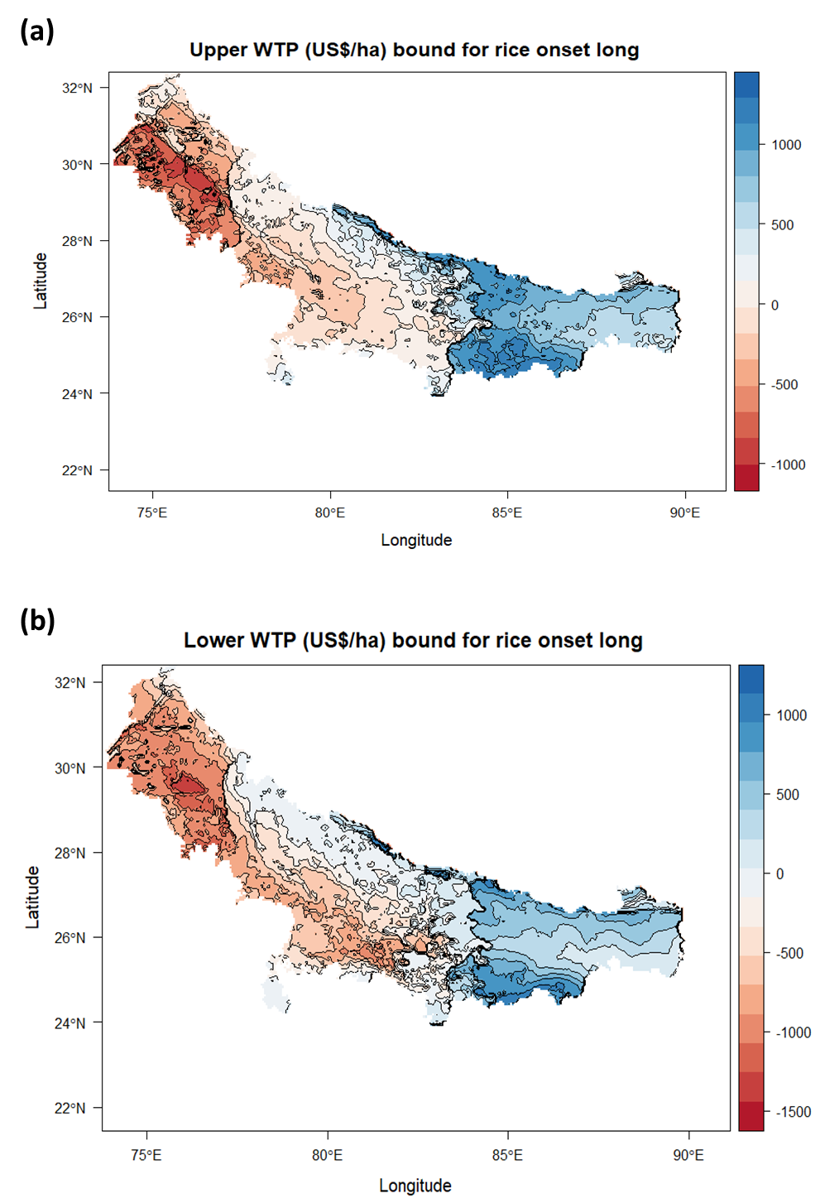

Figure 6: Quantitative analysis of willingness to pay bounds for onset-long strategy

### 3.2.3. Recommended rice planting date strategy per grid cell

Lastly, our risk-based evaluation approach allows us to compare all of the rice planting strategies against each other and identify which strategy performs clearly better and with less risks involved than any other strategy and where several competing strategies might result in similar economic benefits as well as risks. In other words, the above analysis has made binary or pairwise comparisons – while the most important question is: Which strategy should be recommended where? To derive this optimal scenario, we calculate the maximum upper bound WTP among the scenarios and the maximum lower WTP. If one single scenario clearly pays more and clearly induces less risks than the others, we select that scenario for that particular grid cell. As a result, Figure 7 shows the optimal rice planting date strategy.

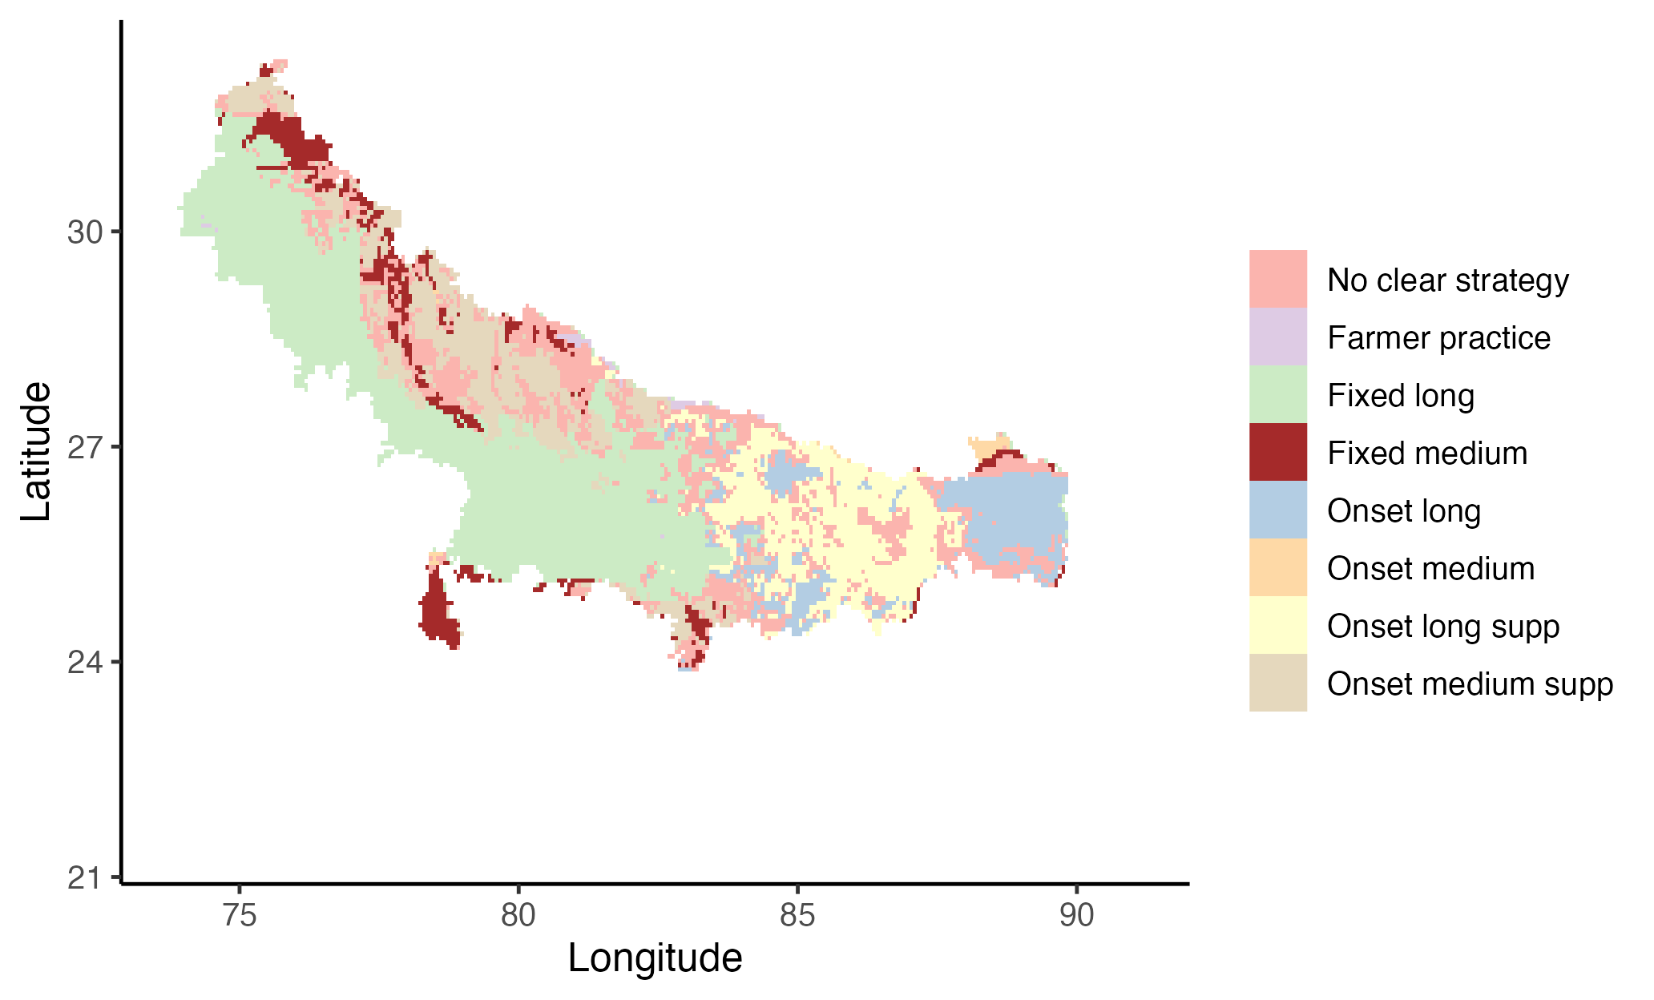

Figure 6: Optimal rice planting date strategy

# 4. Discussion

Importantly and in addition to the findings of Urfels et al. (2022) and Montes et al (2023), our framework shows that in parts of the Eastern Gangetic Plains providing only supplemental irrigation rather than full irrigation is economically beneficial from a risk perspective. The same is true for some areas in the northern parts of the Middle and Western IGP – indicating importance of climatic and soil variability. However, in the Northern and Southern parts of the Western and Middle IGP, we get substantially different outcomes – but also indicating that in these areas multiple rice planting strategies perform equally well and farmers have more flexibility to choose amongst various options for similar results.

In addition to cited prior works (Urfels et al 2022 and Montes et al 2023) which formed the basis of our analysis and used APSIM crop growth model, our results can be compared to two recent studies (Wang 2022, 2024) which rely on regionally calibrated Environmental Policy Integrated Climate (EPIC) agronomic model.

## 4.2. Value of a risk-based evaluation approach in face of climatic risks

The IGP is a hotspot of climate change impacts in that though it supports the most intensive crop production, it also suffers from frequent droughts, volatile monsoon onsets, and heat stress. Farmers delay rice planting in dealing with these environmental and climatic impacts (McDonald et al 2022) thereby suffering substantial yield penalties. Without affordable irrigation infrastructure, timely rice planting becomes very risky for the farmers as evidenced by the recent El Nino event and late monsoon – causing farmers to fallow and reduce rice area. Similar issues of importance of timing and precipitation variability affect other farming systems elsewhere. Recommendations therefore require to consider riskiness evaluation and will need to include also field evaluation of riskiness after the first pass model ex-ante simulations as we do in this paper.

Climate variability and change has prompted a rethinking of how the agricultural research and development community can develop climatic risk proof innovations. These are innovations that are expected to be resilient to present and future climatic shocks. In that regard, crop modelling has become the key approach of assessing how different agronomic innovations perform under varying historical realizations of weather. In this paper, we have demonstrated that a nuanced understanding of risk in evaluating such crop model results can generate insights and provide a basis for making climate risk proof recommendations to smallholder farmers. This approach then allows researchers and farmers to understand the plausible strategies they can follow in order to maximize profits even in years when the weather is extreme.

Besides the farmers and researchers, our approach provides policy decision makers with a prioritization and targeting framework for extension support services that advances only the strategies that are more likely to be accepted by all the farmers in the location. This then reduces wastage of resources especially when risk neutral and profitable technologies are promoted in locations where most farmers are risk averse. The task of figuring out the risk aversion preferences of the farmers in non-trivial and not possible for each of the individual pixels. The approach we use innovatively circumvents this challenge by placing conditions and extent under which any risk averse farmer will still find the proposed strategy beneficial.

## 4.3. Limitations and future research

There are several key limitations to our approach. First, it is computationally heavy especially if the gridded analysis is conducted for larger spatial scales. This challenge can be resolved by reducing the number of pixels in each analysis because the approach uses each pixel separately such that the optimal strategies will not differ based on number of pixels. Second, it requires many years of data to characterize the empirical cumulative distribution function. Our analyses use the period 1982-2015 data which covers enough variation of climatic variability. In the context of long-term trials and surveys, it is difficult to find such longitudinal datasets at scale. Future research that combines these data sources and Monte Carlo simulations would allow the use of the approach in empirically grounded analyses. Third, as compared to other outcomes-based risk analyses like the mean-variance or conditional value at risk approach, our approach simply recommends the best strategy but not an optimal combination or diversified portfolio of options (literature started by Markowitz 1959). Fourth, given that the risk evaluation approach relies on crop model outputs, any limitations of the crop model are propagated in our approach. For example, the gridded APSIM crop model we use has no N limitation and no irrigation to isolate the effect of sowing dates in addition to not having many interactions. While we acknowledge these limitations, they are not necessary for the merit of this paper in that the paper is aimed at showcasing a methodology for evaluating risk regardless of the nature of the crop model used.

# 5. Conclusion

We have shown in this article how a spatially explicit risk-assessment framework can provide evidences on how different agronomic climate adaptation strategies can be adequately evaluated for risk averse farmers. Our work builds on an approach proposed by (Hurley, Koo, & Tesfaye, 2018) and uses computational second order stochastic dominance to calculate lower and upper bounds for which any risk averse farmer will be willing to adopt an alternative rice planting date strategy. Our results for the IGP provide further evidence that early sowing of long duration rice is a suitable strategy for risk averse farmers of the rice-wheat rotation system in Bihar – while planting at state recommended dates and growing medium duration varieties is a better option in the Western and Middle IGP. Importantly, we also show that farmers in the Middle IGP have more flexibility to choose amongst competing options without jeopardizing incomes or increasing risks. With weather variability expected to further increase globally and affecting smallholder farmers disproportionately, our risk-assessment approach can provide a robust and climatic risk proofing framework for evaluating various competing climate adaptation options for risk averse smallholder farmers that not only benefit from higher long-term gains but also seek to minimize losses in any given year.

# Acknowledgements

This study was conducted as part of the Cereal Systems Initiative for South Asia (CSISA; <https://csisa.org/>) supported by the United States Agency for International Development (USAID) and Bill and Melinda Gates Foundation (BMGF). We thank Terrance Hurley for sharing the prototype Matlab code for the computational risk model. The content and opinions expressed in this paper are those of the authors and do not necessarily reflect the views of USAID or BMGF.

# Declaration of Competing Interest

The authors declare that they have no conflict of interest.

# References

Hurley, T., Koo, J., & Tesfaye, K. (2018). Weather risk: how does it change the yield benefits of nitrogen fertilizer and improved maize varieties in sub-Saharan Africa? *Agricultural Economics*, *49*(6), 711-723. <https://doi.org/https://doi.org/10.1111/agec.12454>

Iizumi, T., Yokozawa, M., & Nishimori, M. (2009). Parameter estimation and uncertainty analysis of a large-scale crop model for paddy rice: Application of a Bayesian approach. *Agricultural and Forest Meteorology*, *149*(2), 333-348. <https://doi.org/https://doi.org/10.1016/j.agrformet.2008.08.015>

IPCC. (2022). *Summary for policymakers* (C. U. Press, Ed.). Intergovernmental Panel on Climate Change.

Ishtiaque, A., Singh, S., Lobell, D., Balwinder, S., Fishman, R., & Jain, M. (2022). Prior crop season management constrains farmer adaptation to warming temperatures: Evidence from the Indo-Gangetic Plains. *Science of The Total Environment*, *807*, 151671. <https://doi.org/https://doi.org/10.1016/j.scitotenv.2021.151671>

Kakraliya, S. K., Jat, H. S., Singh, I., Sapkota, T. B., Singh, L. K., Sutaliya, J. M., Sharma, P. C., Jat, R. D., Choudhary, M., Lopez-Ridaura, S., & Jat, M. L. (2018). Performance of portfolios of climate smart agriculture practices in a rice-wheat system of western Indo-Gangetic plains. *Agricultural Water Management*, *202*, 122-133. <https://doi.org/https://doi.org/10.1016/j.agwat.2018.02.020>

Levy, H. (2016). *Stochastic Dominance*. Springer Cham. <https://doi.org/https://doi.org/10.1007/978-3-319-21708-6>

Markowitz, H. M. (1959). *Portfolio Selection*. Yale University Press. <https://doi.org/doi:10.12987/9780300191677>

McDonald, A. J., Balwinder, S., Keil, A., Srivastava, A., Craufurd, P., Kishore, A., Kumar, V., Paudel, G., Singh, S., Singh, A. K., Sohane, R. K., & Malik, R. K. (2022). Time management governs climate resilience and productivity in the coupled rice–wheat cropping systems of eastern India. *Nature Food*, *3*(7), 542-551. <https://doi.org/10.1038/s43016-022-00549-0>

Meyer, J. (1977). Second Degree Stochastic Dominance with Respect to a Function. *International Economic Review*, *18*(2), 477-487. <https://EconPapers.repec.org/RePEc:ier:iecrev:v:18:y:1977:i:2:p:477-87>

Montes, C., Urfels, A., Han, E., & Balwinder-Singh. (2023). Planting Rice at Monsoon Onset Could Mitigate the Impact of Temperature Stress on Rice&ndash;Wheat Systems of Bihar, India. *Atmosphere*, *14*(1), 40. <https://www.mdpi.com/2073-4433/14/1/40>

Nalley, L. L., & Barkley, A. P. (2010). Using Portfolio Theory to Enhance Wheat Yield Stability in Low-Income Nations: An Application in the Yaqui Valley of Northwestern Mexico. *Journal of Agricultural and Resource Economics*, *35*(2), 334-347. Retrieved 2010-08, from <https://ageconsearch.umn.edu/record/93223/files/JARE_Aug2010__10_pp334-347.pdf>

Newport, D., Lobell, D. B., Balwinder, S., Srivastava, A. K., Rao, P., Umashaanker, M., Malik, R. K., McDonald, A., & Jain, M. (2020). Factors Constraining Timely Sowing of Wheat as an Adaptation to Climate Change in Eastern India. *Weather, Climate, and Society*, *12*(3), 515-528. <https://doi.org/https://doi.org/10.1175/WCAS-D-19-0122.1>

Rosenzweig, C., Jones, J. W., Hatfield, J. L., Ruane, A. C., Boote, K. J., Thorburn, P., Antle, J. M., Nelson, G. C., Porter, C., Janssen, S., Asseng, S., Basso, B., Ewert, F., Wallach, D., Baigorria, G., & Winter, J. M. (2013). The Agricultural Model Intercomparison and Improvement Project (AgMIP): Protocols and pilot studies. *Agricultural and Forest Meteorology*, *170*, 166-182. <https://doi.org/https://doi.org/10.1016/j.agrformet.2012.09.011>

Ruzzante, S., Labarta, R., & Bilton, A. (2021). Adoption of agricultural technology in the developing world: A meta-analysis of the empirical literature. *World Development*, *146*, 105599. <https://doi.org/https://doi.org/10.1016/j.worlddev.2021.105599>

Shah, T., Ul Hassan, M., Khattak, M. Z., Banerjee, P. S., Singh, O. P., & Rehman, S. U. (2009). Is Irrigation Water Free? A Reality Check in the Indo-Gangetic Basin. *World Development*, *37*(2), 422-434. <https://doi.org/https://doi.org/10.1016/j.worlddev.2008.05.008>

Suri, T. (2011). Selection and Comparative Advantage in Technology Adoption. *Econometrica*, *79*(1), 159-209. <https://doi.org/https://doi.org/10.3982/ECTA7749>

Tesfaye, K., Khatri-Chhetri, A., Aggarwal, P. K., Mequanint, F., Shirsath, P. B., Stirling, C. M., Jat, M. L., Rahut, D. B., & Erenstein, O. (2019). Assessing climate adaptation options for cereal-based systems in the eastern Indo-Gangetic Plains, South Asia. *The Journal of Agricultural Science*, *157*(3), 189-210. <https://doi.org/10.1017/S0021859619000492>

Urfels, A., Mausch, K., Harris, D., McDonald, A. J., Kishore, A., Balwinder, S., van Halsema, G., Struik, P. C., Craufurd, P., Foster, T., Singh, V., & Krupnik, T. J. (2023). Farm size limits agriculture's poverty reduction potential in Eastern India even with irrigation-led intensification. *Agricultural Systems*, *207*, 103618. <https://doi.org/https://doi.org/10.1016/j.agsy.2023.103618>

Urfels, A., McDonald, A. J., Krupnik, T. J., & van Oel, P. R. (2020). Drivers of groundwater utilization in water-limited rice production systems in Nepal. *Water International*, *45*(1), 39-59. <https://doi.org/10.1080/02508060.2019.1708172>

Urfels, A., McDonald, A. J., van Halsema, G., Struik, P. C., Kumar, P., Malik, R. K., Poonia, S. P., Balwinder, S., Singh, D. K., Singh, M., & Krupnik, T. J. (2021). Social-ecological analysis of timely rice planting in Eastern India. *Agronomy for Sustainable Development*, *41*(2), 14. <https://doi.org/10.1007/s13593-021-00668-1>

Urfels, A., Montes, C., Balwinder, S., van Halsema, G., Struik, P. C., Krupnik, T. J., & McDonald, A. J. (2022). Climate adaptive rice planting strategies diverge across environmental gradients in the Indo-Gangetic Plains. *Environmental Research Letters*, *17*(12), 124030. <https://doi.org/10.1088/1748-9326/aca5a2>

Wang, X., Folberth, C., Skalsky, R., Wang, S., Chen, B., Liu, Y., Chen, J., & Balkovic, J. (2022). Crop calendar optimization for climate change adaptation in rice-based multiple cropping systems of India and Bangladesh. *Agricultural and Forest Meteorology*, *315*, 108830. <https://doi.org/https://doi.org/10.1016/j.agrformet.2022.108830>

Wang, X., Wang, S., Folberth, C., Skalsky, R., Li, H., Liu, Y., and Balkovic, J. 2024. “Limiting global warming to 2 oC benefits building climate resilience in rice-wheat systems in India through crop calendar management.” *Agricultural Systems* 213: 103806. Doi: <https://doi.org/10.1016/j.agsy.2023.103806>.

1. A similar computational willingness to pay bounds approach to second order stochastic dominance is used in the finance literature to evaluate put and call options (for details, see Levy 1985).
2. R and octave code to replicate the analyses for a subset of the data are available here: <https://eia2030-ex-ante.github.io/WTP_Bounds_SOSD_Risk_Model/>.
3. The gridded APSIM crop simulation model setup and results are available here: <https://git.wageningenur.nl/urfel001/igp-simulation-setup>.
4. We did robustness analyses with farmer practice as baseline in a limited geographical space. The decision of which scenario to use as the baseline does not alter the results.